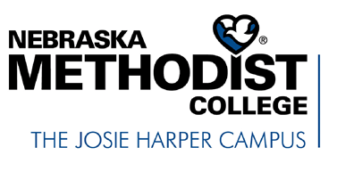
FERPA Release for Recommendation/Reference Request
In accordance with the Family Educational Rights and Privacy Act of 1974 (FERPA), Nebraska Methodist College maintains the confidentiality of student’s records and requires written authorization for the release of this information.
Printed Name of Student: Id #:
- I authorize to serve as a reference and to write a letter of recommendation on my behalf for the purposes of

- This information may be released to:
Name of Institution/Business:
Address:
City, State & Zip Code:
Attention:
- I authorize the above named person to release information about me and provide an honest evaluation from his or her knowledge of my qualifications. This valuation could be based upon my involvement in activities or organizations outside the classroom or my performance in his or her class(es) and/or clinical/fieldwork.

- I authorize him/her to provide any academic information, including but not limited to my grades, GPA, class rank, scholarships, honors, awards, and comments from other instructors including, but not limited to, lab instructors, clinical preceptors and/or fieldwork educators.
□ I waive my right to review a copy of the letter of recommendation at any time in the future.

Student Signature: Date:

Please return this form to the individual writing the recommendation by mail, fax, or email.

