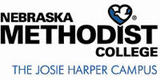
POLICIES AND PROCEDURES
SUBJECT: COVID-19 Self-Disclosure of Positive Screening
REVIEWED/REVISED: 6/16/20;
PURPOSE: To provide guidance on mandatory disclosure of positive COVID-19 test result.
POLICY OWNER: Chief Institutional Effectiveness Officer
POLICY:
NMC requires all students, faculty, and staff to self-disclose a positive COVID-19 test result to Campus Health. To self-disclose, please call Campus Health at (402) 354-7211.

