***NMC EMPLOYEE/STUDENT UPDATE March 26, 2020—RE: Coronavirus (COVID-19)***

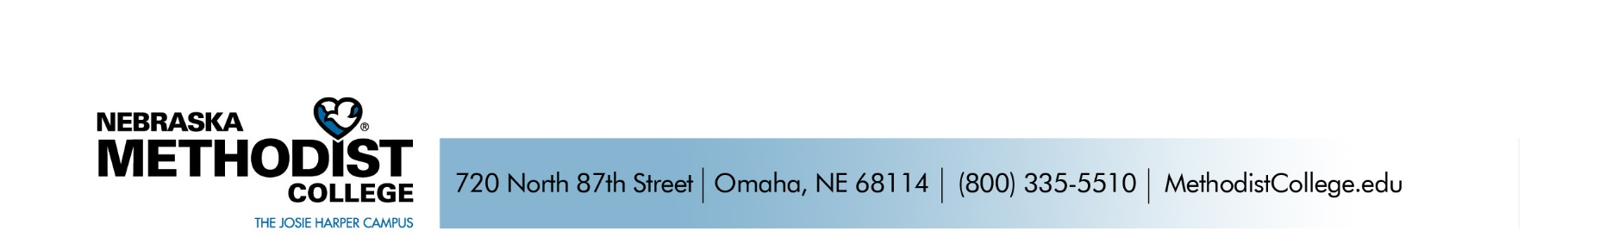
Dear NMC Community,

In an effort to bring you up to speed on what’s happening at NMC. Please note the following information:

- Campus Is Open: We need your help in keeping our campus open! If you are feeling ill at all, DO NOT COME TO CAMPUS OR GO TO WORK. Please do not risk your health and safety or that of your classmates, faculty, staff, co-workers and patients if you are sick. Stay home and contact Campus Health or your health care provider by phone.

We all need to continue to practice good hand hygiene and social distancing in order to mitigate coronavirus spread and keep our campus community open and safe. We want our campus to remain an open resource to you through this crisis—but we must all do our part!

Campus remains open for students and employees to access resources. However, in efforts to maintain efficient cleaning of our campus facilities, a reminder that Clark Building 3rd floor classrooms, 501 Building 2nd floor study areas/classrooms, Fitness Room, Deja Brew and Micro Market are closed. Library, business office, registrar and financial aid have transitioned to a virtual space, with staff supporting you remotely.

The Student Engagement Center, 2nd floor Clark classrooms, computer lab as well as the 1st floor Clark lobby/dining area and Chapel remain open for use. Please practice social distancing and do not crowd in the study rooms. Most student and academic support services are working remotely, but are available by phone, email, FaceTime, WebEx, Zoom, etc.

The NMC food pantry is open to all students. It continues to be heavily utilized and is need of pantry items and/or monetary donations—please contact Dr. Lisa Johnson if you are interested in shopping the pantry or are able to contribute.

- Wellbeing Support Resources: Is Coronavirus news getting to you? Need someone to talk to? Finding it hard to get through a day? Best Care EAP (employees) and SAP (students) are here to help! Counselors are available through telehealth services. Students—Kathy Dworak, LIMHP in Campus Counseling, Sam Barnhart, PA-C in Campus Health or Rev. Chad Anglemyer, pastor with our local United Methodist Churches, are waiting to hear from you. Contact information is available on the attached Student Services Resource listing.

- Travel: It’s critical for your health and the health of our campus and health system population that you contact Employee Health (employees) or Campus Health (students) for instruction on care if you have the following situations:

    - You have traveled more than 100 miles from the Omaha metro area or traveled by cruise ship in the last 21 days, and before you return to work
    - You have symptoms of fever, cough, sore throat or difficulty breathing
    - You don’t have symptoms but have been exposed (within 6 feet of and for 10 minutes or more without wearing PPE) to a known or suspected COVID-19 carrier
Employee and Campus Health are working closely with our Infectious Disease experts to develop daily protocols based on the most current status of the coronavirus outbreak in our community.
- Graduation: As previously communicated, in-person hooding and commencement ceremonies scheduled for May 1, 2020 are cancelled. NMC plans to confer degrees as scheduled. Students that are anticipating graduating this spring—communication is coming your way on alternate opportunities to celebrate your academic achievements!

I know this is a challenging time, but we will persevere together. Please let me know if there is anything NMC can do to help you and know we are thinking of you. Stay in touch with each other, be kind to one another, and reach out to our campus immediately if you are experiencing difficulties.

Take care and be well NMC,

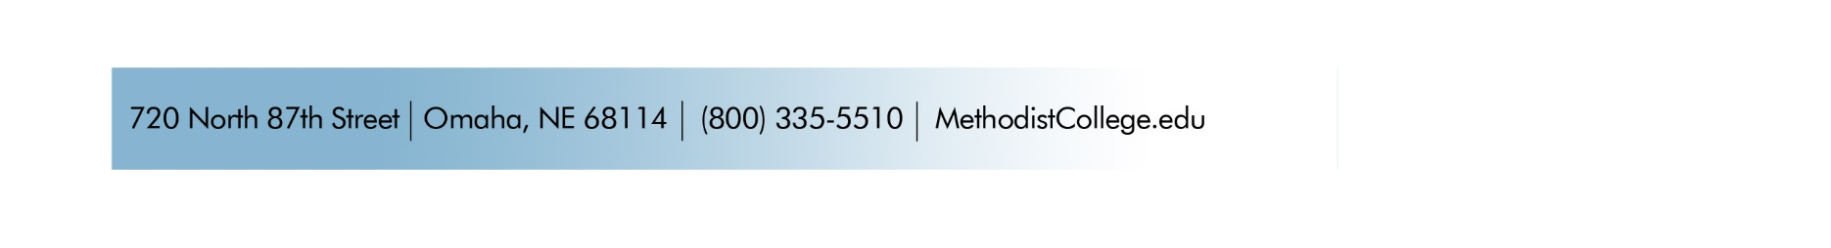
Deb Carlson

Deb Carlson, PhD.
President & CEO
Nebraska Methodist College

